EXPERIMENT 1
TITLE -Write basic C++ programs demonstrating input/output operations, decision-making statements (if-else, switch-case), looping statements (for, while, do-while), arrays and string handling.
CODE- 1.
Problem Statement : Write basic C++ programs demonstrating:
● Input/Output operations.
Code :
#include <iostream>
#include<string>
using namespace std;
int main()
{
string a;
cout << "Enter a String : ";
cin >> a; cout << a;
return 0;
}
Output :
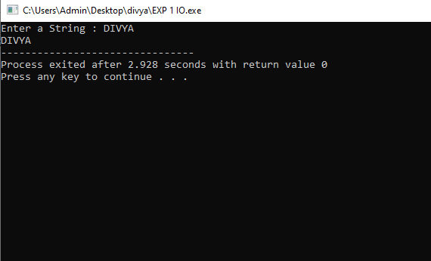

Experiment 1
Problem Statement : Write basic C++ programs demonstrating:
● Class and object definitions.
Code :
#include <iostream>
#include <string>
using namespace std;

class Store
{
public:
// Data members
string item_name;
int price;
float discount;
};

int main()
{
// Object creation
Store Item1;

// Assigning values to data members
Item1.item_name = "Pencil";
Item1.price = 5;
Item1.discount = 4.99;

// Displaying values
cout << "The Item is : " << Item1.item_name << "\n";
cout << "The Price is : " << Item1.price << "\n";
cout << "The Discount is : " << Item1.discount << "\n";
return 0;
}
Output :
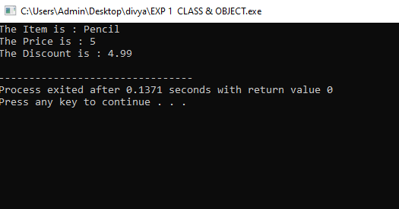
Experiment 1
Problem Statement : Write basic C++ programs demonstrating:
● Control statements (if-else,)
Code :
#include <iostream>
using namespace std;

int main()
{
int a, b;

cout << "Enter Two Numbers: ";
cin >> a >> b;

if (a > b)
{
cout << "The Number Entered First is the Largest";
}
else
{
cout << "The Number Entered Second is the Largest";
}

return 0;
}
Output :
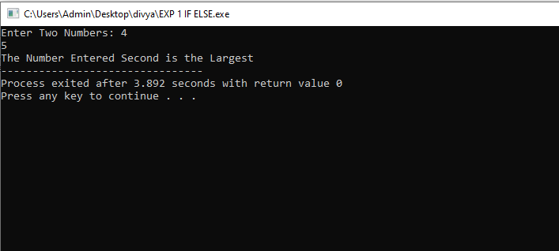

Experiment 1
Problem Statement : Write basic C++ programs demonstrating:
● Control statements (Switch Case).
Code :
#include <iostream>
using namespace std;

int main()
{
int a, b;
char n;

cout << "Enter Two Numbers: ";
cin >> a >> b;

cout << "Enter Operation (+, -, *, /): ";
cin >> n;

switch (n)
{
case '+':
cout << "Result: " << a + b;
break;

case '-':
cout << "Result: " << a - b;
break;

case '*':
cout << "Result: " << a * b;
break;

case '/':
cout << "Result: " << a / b;
break;

default:
cout << "You Entered a Wrong Operation";
}

return 0;
}
Output :
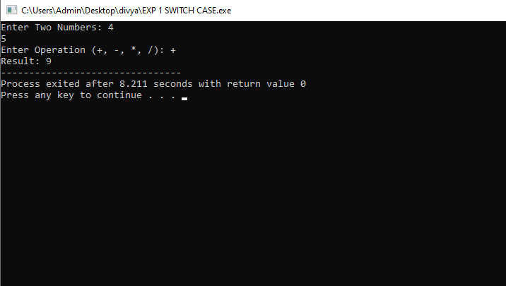
Experiment 1
Problem Statement : Write basic C++ programs demonstrating:
● Looping (for loop)
Code :
#include <iostream>
using namespace std;

int main()
{
int n;

cout << "Enter value of n: ";
cin >> n;

int sum = 0;

// Using for loop
for (int i = 1; i <= n; i++)
{
sum = sum + i;
}

cout << "The sum of first N natural numbers by for loop is: "
<< sum << endl;

return 0;
}
Output:
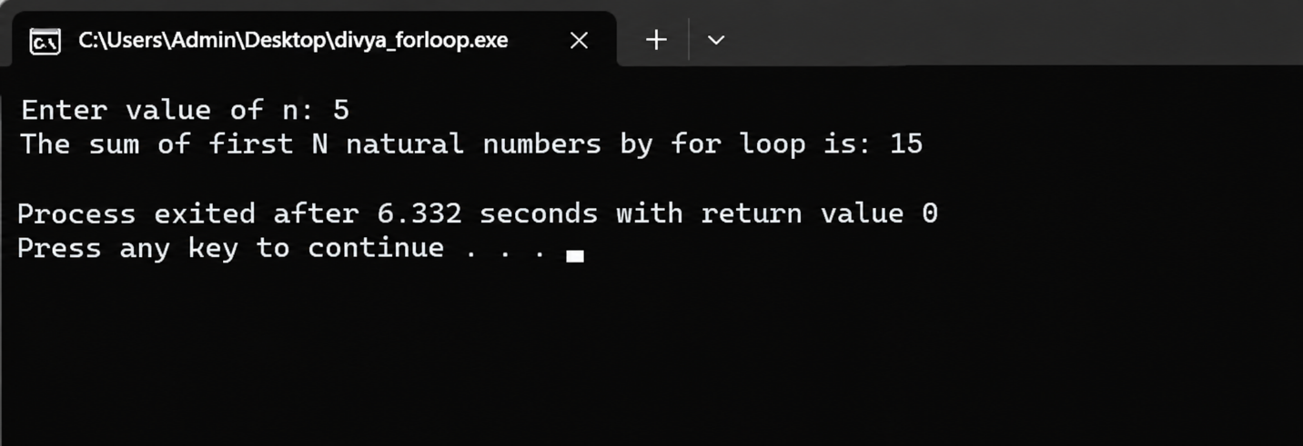

● Looping (while loop)
Code:
#include <iostream>
using namespace std;
int main()
{
int n;
cout << "Enter value of n: ";
cin >> n;
int sum = 0;
int i = 1;
// Using while loop
while (i <= n)
{
sum = sum + i;
i++;
}
cout << "The sum of first N natural numbers by while loop is: "
<< sum << endl;
return 0;
}

Output:

● Looping (do-while loop)

Code:
#include <iostream>
using namespace std;
int main()
{
int n;
cout << "Enter value of n: ";
cin >> n;
int sum = 0;
int i = 1;

// Using do-while loop
do
{
sum = sum + i;
i++;
}
while (i <= n);
cout << "The sum of first N natural numbers by do-while loop is: "
<< sum << endl;
return 0;
}

Output:

Experiment 1
Problem Statement : Write basic C++ programs demonstrating:
● String handling.
Code :
#include <iostream>
#include <string>

using namespace std;

int main()
{
string Name = "Divya ";
string Surname = "Bhagat";

string Full_Name = Name + Surname;

cout << "My Full name is : " << Full_Name;

return 0;
}
Output:

Experiment 2-
Title -Write a C++ program to demonstrate class declaration, object creation, data members, member functions and access of class members.
Code-
#include <iostream>
using namespace std;
// Class declaration
class Student {
public:
// Data members
string name;
int rollNo;
float marks;
// Member function
void display() {
cout << "Student Name: " << name << endl;
cout << "Roll Number: " << rollNo << endl;
cout << "Marks: " << marks << endl;
}
};
int main() {
// Object creation
Student s1;
// Accessing and assigning data members
s1.name = "Divya";
s1.rollNo = 07;
s1.marks = 99.99;
// Calling member function
s1.display();
return 0;
}
Output -
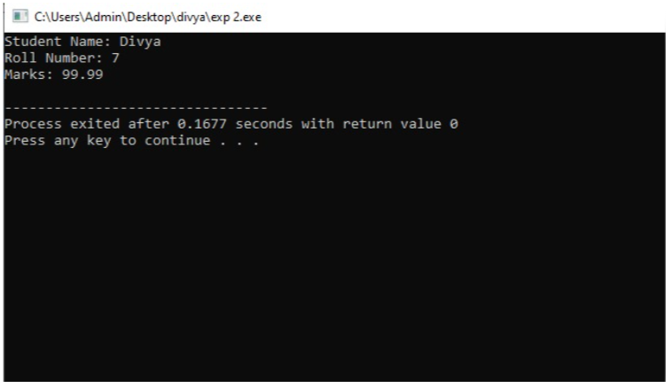

Experiment 3
Title - Write a C++ program to demonstrate default, parameterized and copy constructors and understand the order of constructor invocation.
Code- 1. Default constructor
#include <iostream>
using namespace std;

class Student
{
int id;
string name;

public:
Student()
{
id = 07;
name = "DIVYA";
}

void display()
{
cout << "RollNo: " << id << endl;
cout << "Name: " << name << endl;
}
};
int main()
{
Student s1;
s1.display();
return 0;
}
Output –
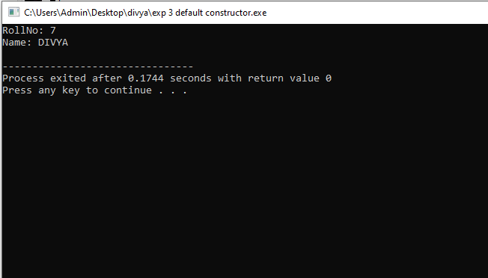

Experiment 3
Title - Write a C++ program to demonstrate default, parameterized and copy constructors and understand the order of constructor invocation.
Code- 2. Parameterized constructor
#include <iostream>
using namespace std;

class Student
{
int id;
string name;

public:
Student()
{
id = 07;
name = "Divya";
}

void display()
{
cout << "RollNo: " << id << endl;
cout << "Name: " << name << endl;
}
};

int main()
{
Student s1;
s1.display();

return 0;
}
Output –
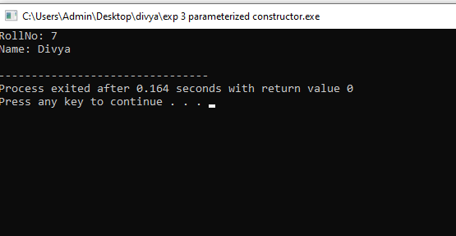

Experiment 3
Title - Write a C++ program to demonstrate default, parameterized and copy constructors and understand the order of constructor invocation.
Code- 2. Copy constructor
#include <iostream>
using namespace std;
class Student
{
int id;
string name;
public:
Student(int i, string n)
{
id = i;
name = n;
}
Student(const Student &s)
{
id = s.id;
name = s.name;
}
void display()
{
cout << "RollNo: " << id << endl;
cout << "Name: " << name << endl;
}
};

int main()
{
Student s1(07, "Divya");
Student s2(s1);
s2.display();
return 0;
}
Output-
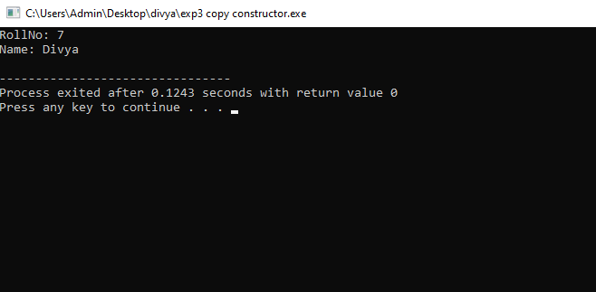
Experiment 6
Title - Write a C++ program to implement a COURSE class with course name, course code, credits, maximum students and an array of enrolled students. MaxStudents: Maximum number of students that can enroll in the course
Code-
#include <iostream>
using namespace std;
class COURSE
{
public:
string courseName;
string courseCode;
int credits;
int maxStudents;
string students[50];
int count;
void input()
{
cout << "Enter Course Name: ";
cin >> courseName;
cout << "Enter Course Code: ";
cin >> courseCode;
cout << "Enter Credits: ";
cin >> credits;
cout << "Enter Maximum Students: ";
cin >> maxStudents;

count = 0;
}

void enroll()
{
if (count < maxStudents)
{
cout << "Enter Student Name: ";
cin >> students[count];
count++;
cout << "Student enrolled successfully.\n";
}
else
{
cout << "Course is full.\n";
}
}
void display()
{
cout << "\nCourse Name: " << courseName << endl;
cout << "Course Code: " << courseCode << endl;
cout << "Credits: " << credits << endl;
cout << "Maximum Students: " << maxStudents << endl;

cout << "Enrolled Students:\n";
for (int i = 0; i < count; i++)
{
cout << students[i] << endl;
}
}
};
int main()
{
COURSE c;
c.input();
c.enroll();
c.display();
return 0;
}

Output-
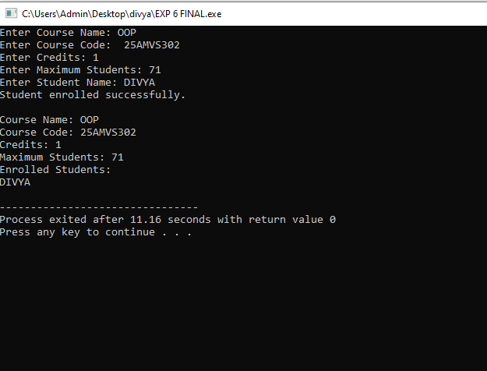
Experiment 9
Title - Write C++ programs to demonstrate single inheritance and multilevel inheritance using suitable real-world examples.
Code – 1. Single Inheritance
#include<iostream>
using namespace std;
class vehicle{
public:
void start(){
cout<<"vehicle started"<<endl;

}
};
class car:public vehicle{//single iheritance
public:
void drive(){
cout<<"car is driving"<<endl;
}
};
int main(){
car c;
c.start();
c.drive();
return 0;
};
Output –
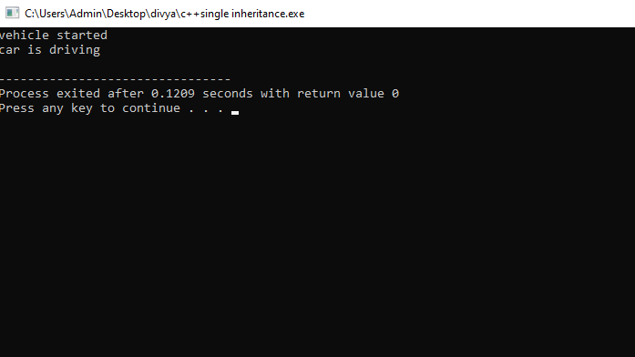

Experiment 9
Code – 2. Multilevel inheritance
#include<iostream>
using namespace std;
class Animal{
public:
void eat(){
cout<<"Eating"<<endl;
}
};
class Mammal:public Animal{
public:
void walk(){
cout<<"working"<<endl;
}
};
class Dog:public Mammal{
public:
void bark(){
cout<<"barking"<<endl;
}
};
int main(){
Dog d;
d.eat();
d.walk();
d.bark();
return 0;
}
Output –
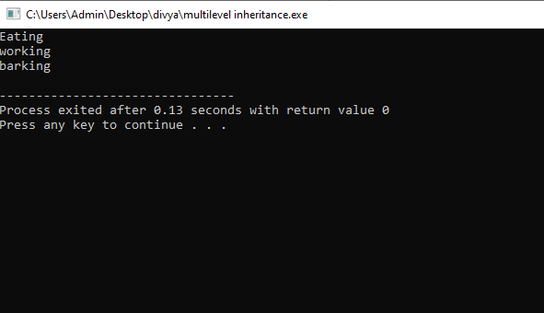

Experiment 9

Code – 3. Multiple Inheritance
#include<iostream>
using namespace std;
class Engine{
public:
void showEngine(){
cout<<"Engine type:petrol"<<endl;
}
};
class Wheels{
public:
void showWheels(){
cout<<"number of wheels is 4"<<endl;

}
};
class car:public Engine,public Wheels{
//multiple inheritance
public:
void display(){
cout<<"This is a car"<<endl;

}
};
int main()
{

car c;
c.showEngine();
c.showWheels();
c.display();
return 0;
}
Output-
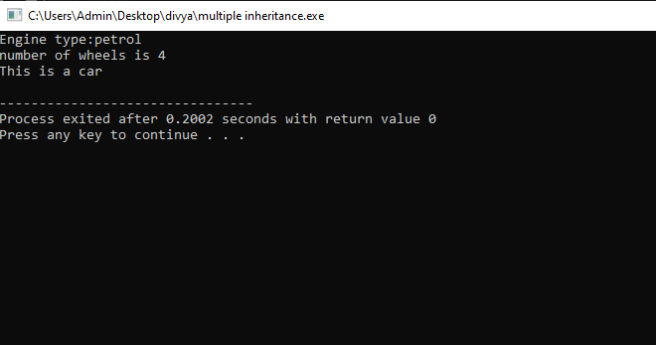

Experiment 9
Code – 4. Hierarchical Inheritance
#include <iostream>
using namespace std;

class Animal {
public:
void eat() {
cout << "Animal is eating" << endl;
}
};

class Dog : public Animal {
public:
void bark() {
cout << "Dog is barking" << endl;
}
};

class Cat : public Animal {
public:
void meow() {
cout << "Cat is meowing" << endl;
}
};

int main() {
Dog d;
d.eat();
d.bark();

Cat c;
c.eat();
c.meow();

return 0;
}
Output-
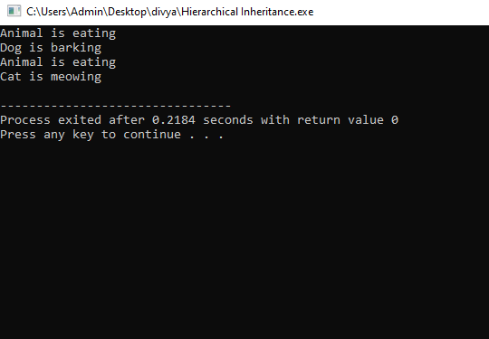

Experiment 9
Code – 5. Hybrid Inheritance

#include <iostream>
using namespace std;

class Animal {
public:
void eat() {
cout << "Animal is eating" << endl;
}
};

class Dog : public Animal {
public:
void bark() {
cout << "Dog is barking" << endl;
}
};

class Cat : public Animal {
public:
void meow() {
cout << "Cat is meowing" << endl;
}};
class Puppy : public Dog, public Cat {
public:
void play() {
cout << "Puppy is playing" << endl;
}
};
int main() {
Puppy p;
p.bark();
p.meow();
p.play();
return 0;
}
Output-
